Open Questions Data Management

Work with a partner. Use a novel you are currently reading. Open it to any page. Count the number of letters in each of the first 100 words.
Record your data in the following tally chart:
Number of letters | Tally of number of words

Graph your data.
Why did you choose that type of data?
Who might be interested in this data?

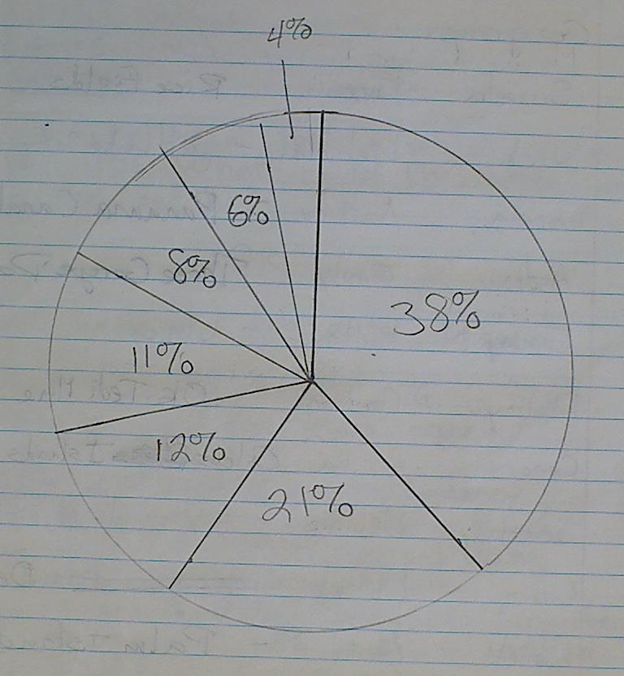
Look at the above graph. What might it represent?
The mean for a set of data is 105. What could the other numbers in the set be?

Look at the data below.
65, 36, 92, 81, 100, 766
What could this data represent?

Create a set of data that has 5 numbers, a mean of 26 and a median of 25.

The mean of a set of data is 130. The mode is 110. There are 7 numbers in the set. What could the set be?

Create a set of data with a value missing. Give the data’s mean including the missing value.

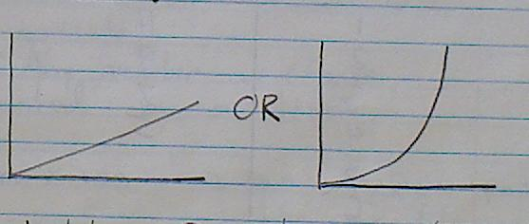
Create a table of values that might represent one of the graphs above. Explain how you knew to choose these numbers.

The chance of winning a prize in Roll up the Rim to Win is not likely. If a class of 28 each bought a coffee, how many would you expect to win?

What would be a real life event that has a probability of 60%?

