Open questions grade 7 NS and N

Gavin and Emmy both bought packages of pencils. The number of pencils in each package is the same. How many pencils could there be in one package?

Find as many whole numbers as you can that have square roots between 1 and 20.

8 squared is 64. What does squared mean?

3 square rooms have the following wall lengths:
    - Room 1: 4m
    - Room 2: 3m
    - Room 3: 12m
Write an equation using exponents that would show the total area of the 3 rooms altogether.

A square room has an area of more than 100m² .
- How long is each wall?
- What is the perimeter of the room?

Surveying a class, it was discovered that 27 out of 36 students finished their homework. Write the number of students that finished their homework in as many ways as you can think of.

A population has a percentage of people under 16 years old at 60%.
Option a)What are three different options for the number of total people for the total people in the population?
Option b) How many people would be under 16 year old if the total population is 720?

A cross section of a shoreline is shown below.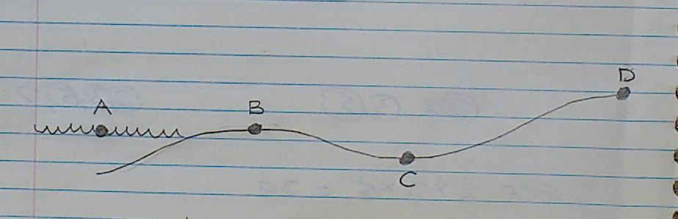
The elevation of the points are as follows:
A: 0m
B: 2m
D: 10m

What might the elevation of point C be?

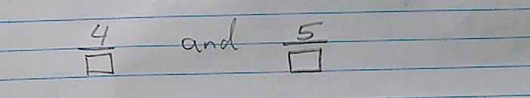
Choose a single value to replace both blanks.
Name a fraction that is between the two fractions that you created.

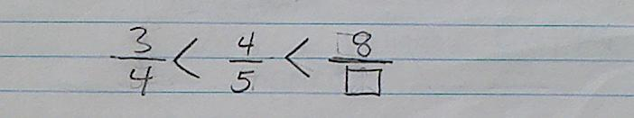
Fill in the missing value. Explain how you know this to be true.

Three fractions use the following digits. Each digit appears only once.
4, 1, 8, 2, 5, 3
- Write the three fractions and put them in order.
- Add the three fractions together.

Represent five halves.

3 $\frac{1}{2}$=seven halves
Use pictures, numbers or words to explain/ prove.

Choose a mixed number. Describe it in as many ways as you can.

24.99 + 6.95
Show this in as many ways as you can without using a calculator.
Choose one of the following and represent it in as many ways as possible:
$4÷0.5$ or 6 x 0.2

Choose one of the following numbers and write a sentence or draw a picture of what the decimal might represent.
0.963 or 490.718

Fill in the missing values.
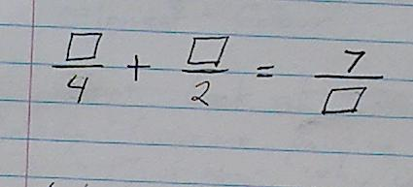

Create a sentence that uses each of the following words and numbers:
0.6, little, decimal, 0.01
OR
25, power, less, 3

The answer to an equation that has brackets, multiplication, 0.25, an exponent and addition is 75. What could the equation be?

The answer to an equation that has brackets, division, a square root and the addition of two fractions is 50. What could the equation be?

A decimal is greater than $\frac{1}{8}$ and less than $\frac{1}{5}$. What could the decimal be?

Jacob has borrowed $10312.15 from the Bank of James. He has paid most of the money back. Show much he has left to pay back as a percentage. Use the percentage to calculate the exact amount left owing.

Choose a statistics to convert to a percentage (all numbers in millions).
Number of children in the world: 2200
Number of children that live in poverty: 1000
Number of children without adequate shelter: 640
Number of children without access to safe water: 400
Does seeing the stat in a percentage make it easier to understand or harder? Why?

Look at the equation below:
2x + y = 36
What could x and y be to make the equation true?

