Patterning and Algebra Open Questions

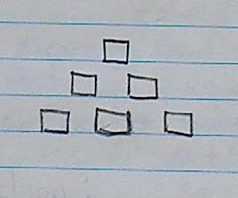This shape is the 3rd term in a pattern. What could the pattern be?

How are these two expressions alike? How are they different?

2x-4 4x-6

Which of these patterns are most alike? Why?
- 2, 5, 8, 11, 14….
- 2, 7, 12, 17, 22, 27….
- 3, 6, 9, 12, 15….

What does = mean?

A pattern is represented by an expression where the variable x represents the term number.
- Create an algebraic expression using multiplication and subtraction to represent the pattern.
- Create a table of values for your expression.
- Graph it.
A pattern has the numbers 16, 4, and 20 in it. What could the pattern be? Create a table of values and an algebraic expression for your expression.

The answer is x = 7. What is the question?

